ASSIGNMENT 1

DATA VISUALISATION

Name: Nazneen Kausar

Date of Submission: 05/11/23

Table of Contents

First Task 3

Policies and Procedures: 3

Second Task 4

Excel 4

GDP Task 4

The Data 8

Third Task 14

*Tableau* 14

Reflection………………………………………………………………………………………………………………………………………………………………….18

# First Task

## Policies and Procedures:

The wealth of Nations database is an extremely confidential data encompassing the GDP of the various countries depending on various factors affecting it. Even though some specific policies and procedures vary from organization to organization; below are some key concepts to remember when handling sensitive data.

When working with data, it is important to adhere to certain policies to ensure its security and privacy. Some key policies include obtaining consent from individuals before collecting their data, storing data securely, and only using it for the intended purpose. This ensures that people are aware of how their information will be used and gives them the opportunity to make an informed decision.

Next, data should be stored securely to protect it from unauthorised access or breaches. This can involve measures such as encryption, firewalls, and access controls. By implementing strong security practices, organisations can safeguard sensitive data and maintain the privacy of individuals.

Another important policy is to only use the collected data for the intended purpose. This means that organisations should not use the data for any other reason without obtaining further consent. It is essential to respect the privacy rights of individuals and ensure that their data is not misused or shared without permission.

In addition, organisations should have policies in place to handle data breaches effectively. This includes having a plan to detect, respond to, and mitigate any security incidents that may occur. Having a complete Disaster recovery plan is also required when data is involved. Data Security and Integrity is a key factor in keeping data secured from unidentified threats and calamities. By having a clear process in place, organisations can minimise the impact of a breach and protect the data of individuals.

Lastly, it is crucial to comply to with relevant company laws and regulations regarding data protection and privacy. By following these policies, organisations can work with data in a responsible and ethical manner, prioritising the security and privacy of individuals.

# Second Task

## Excel:

## GDP Task:

1. Setting up a password to protect the workbook.

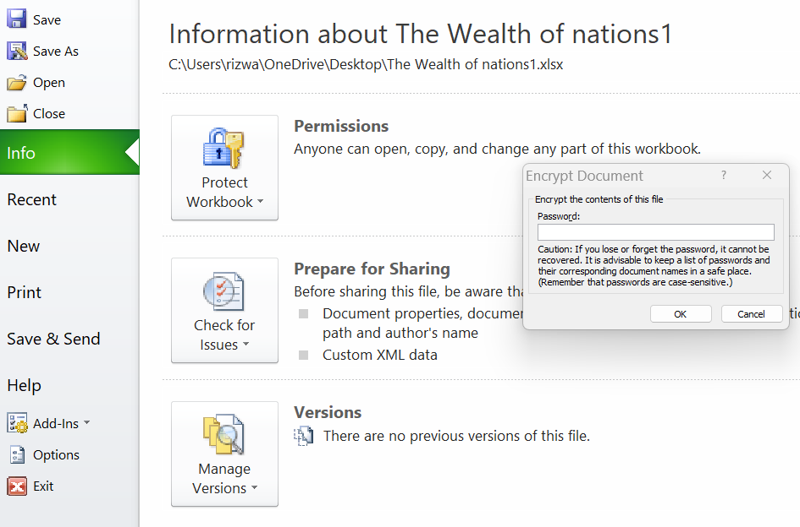

2. Highlighting column C and changing the data to display in British Pound symbol.

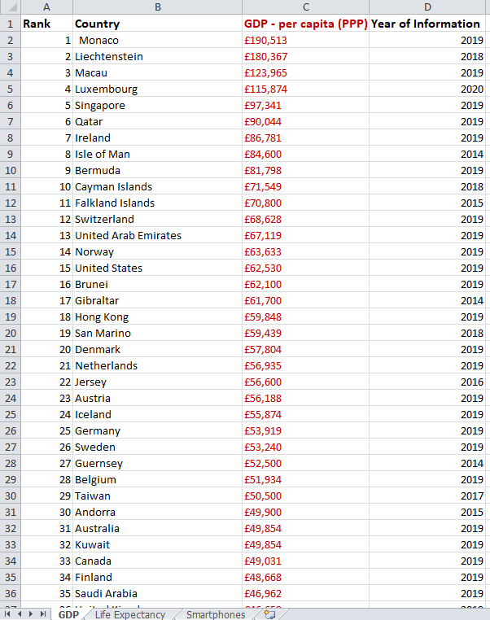

3. Turning the GDP sheet into a table.

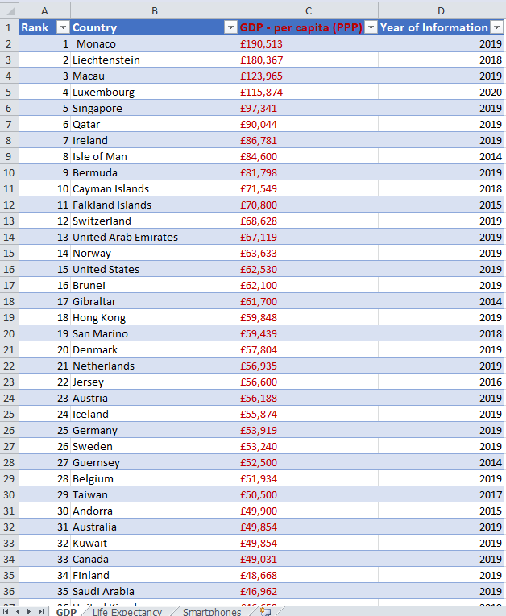

4. Filtering the table in order to display only the information for 2019.

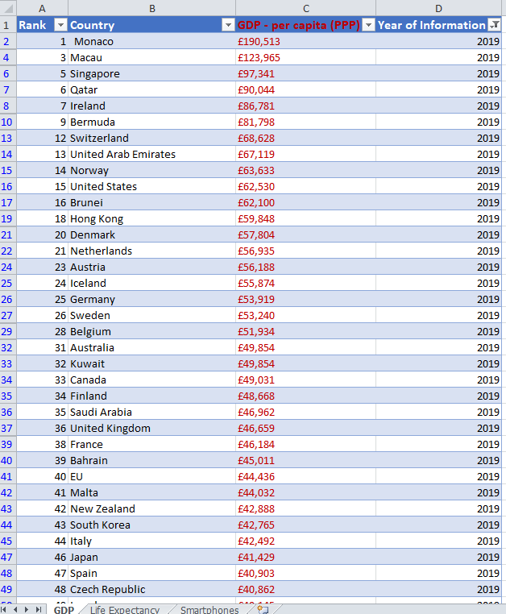

5, 6, 7.

Creating a chart that will only display the following data ‘Rank, Country and GDP - per capita (PPP) including a suitable title, X and Y axis. Moved the chart to a new sheet and labelled it as “GDP-per capita (PPP) in 2019”.

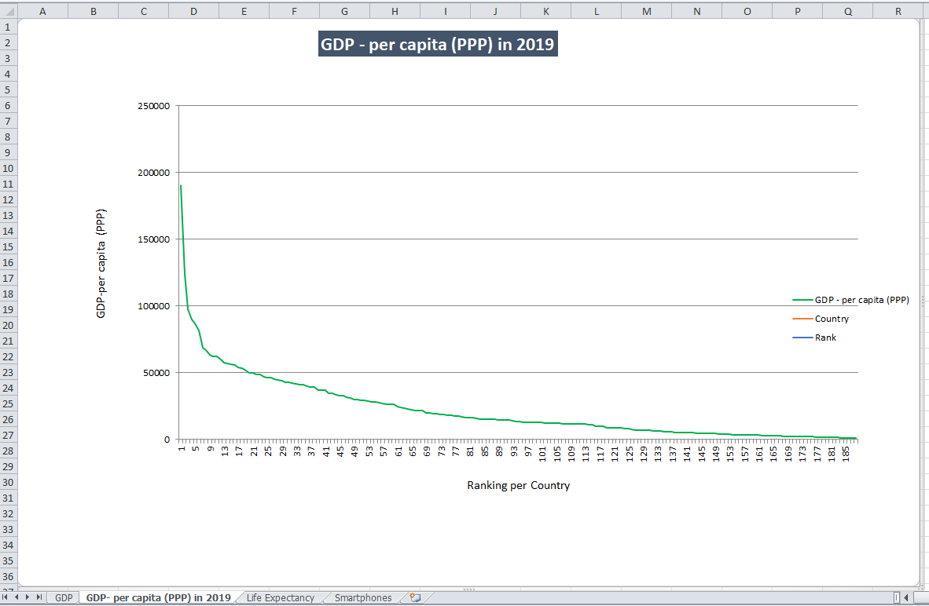

8. Creating a sort for the top 20 highest ranking countries.

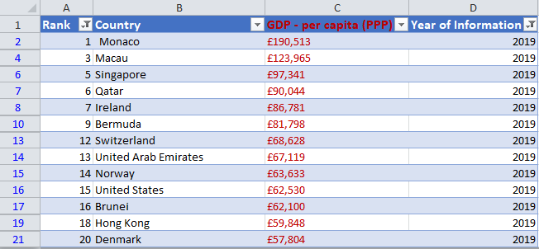

9. Creating a new Bar chart to display the 20 highest ranking countries from the sort and then moving the chart to be underneath the table.

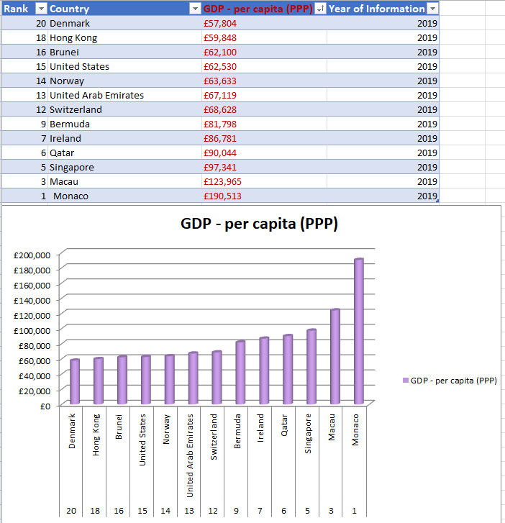

10. Colouring the background by highlighting the area underneath the table.

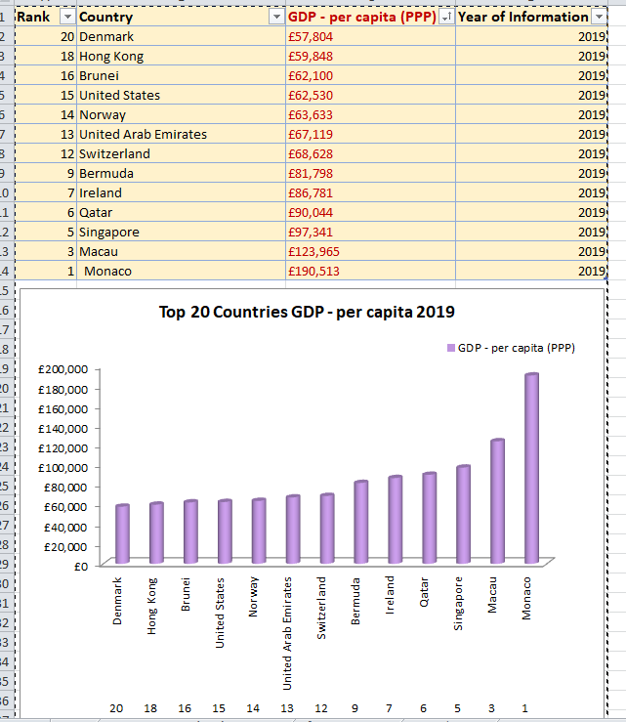

## The Data:

Recording the macro to copy the sheet .

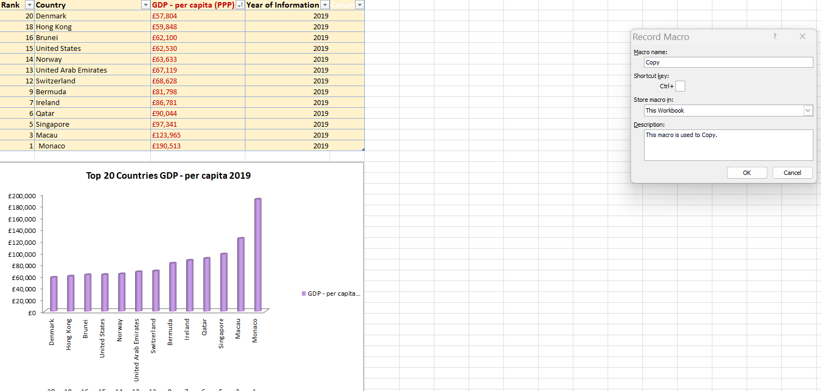

Assigning the macro to “Copy” button.

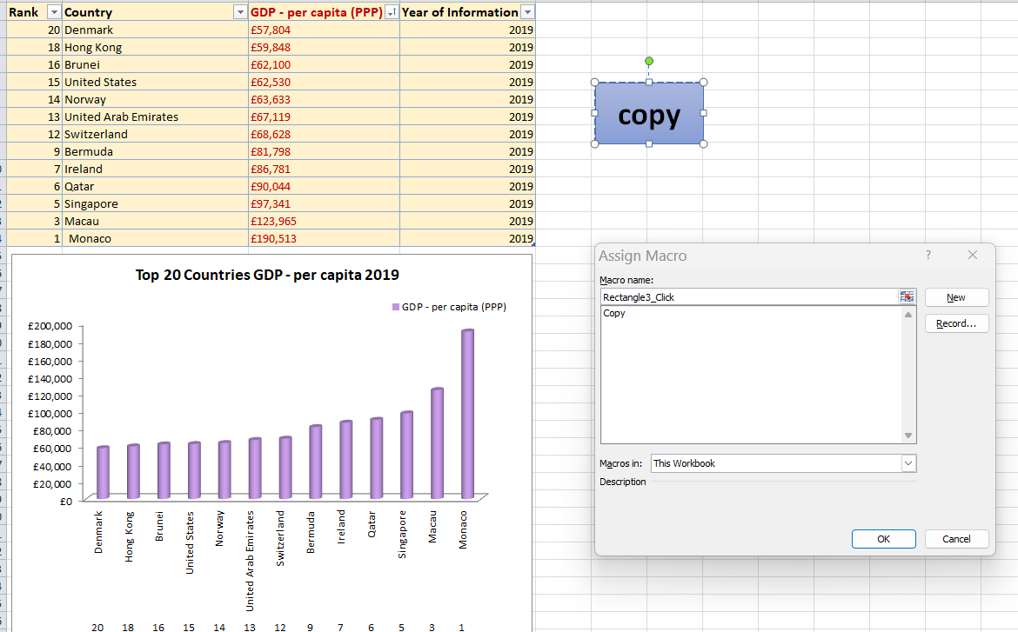

Recording the macro to print the sheet .

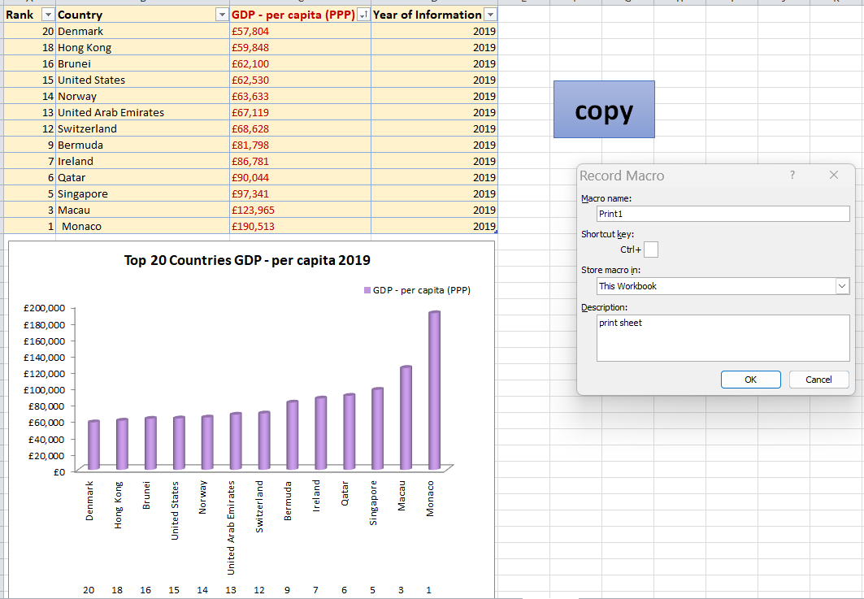

Assign macro to “PRINT” button

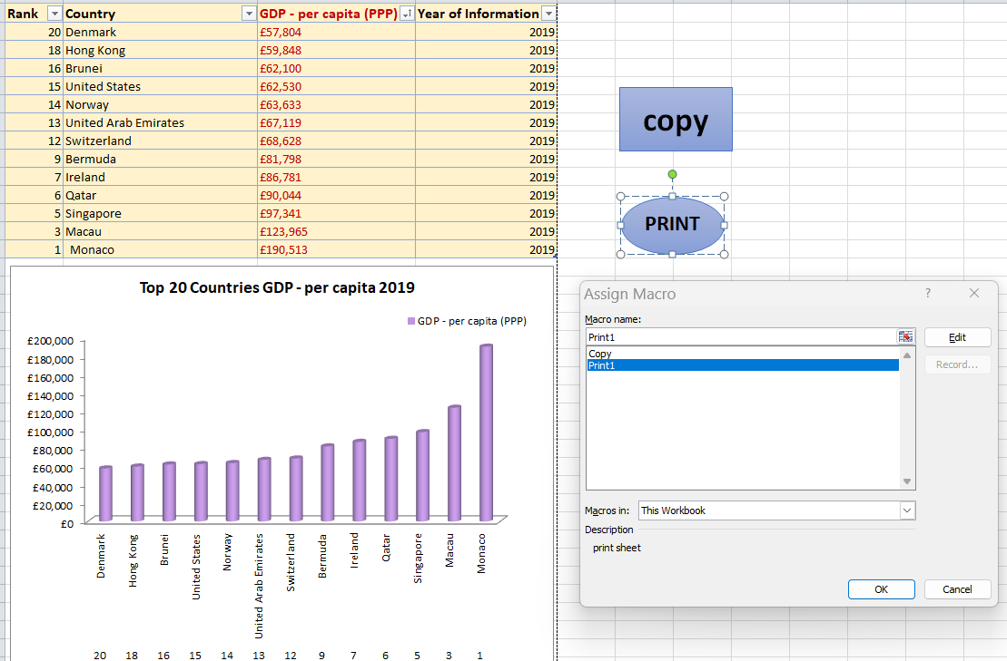

Record macro to Save the sheet.

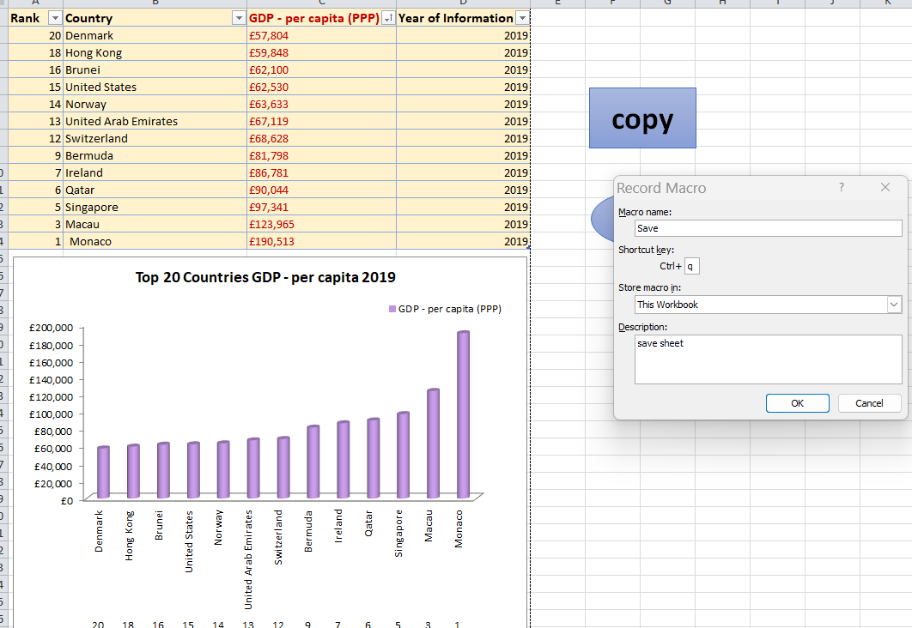

Assign save macro to “SAVE” button

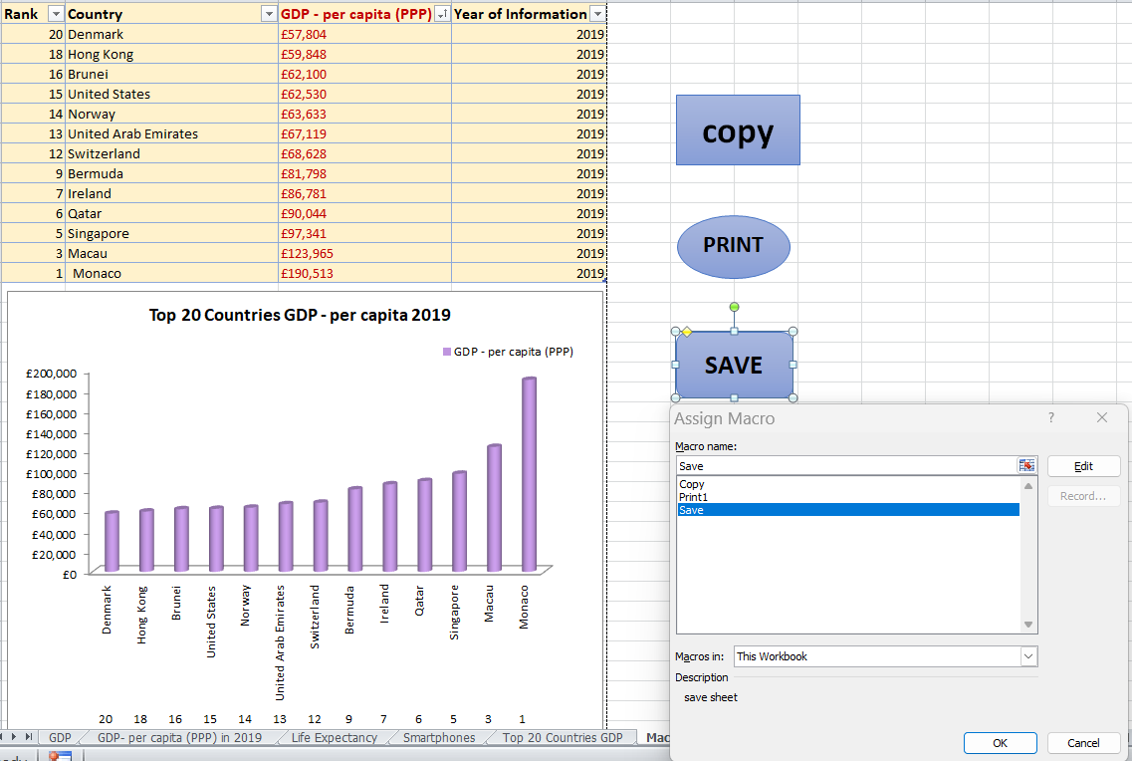

2. Using the copy macro, copying the sheet and then pasting it into a new word document “‘GDP (Gross domestic product)’ ”keeping the formatting.

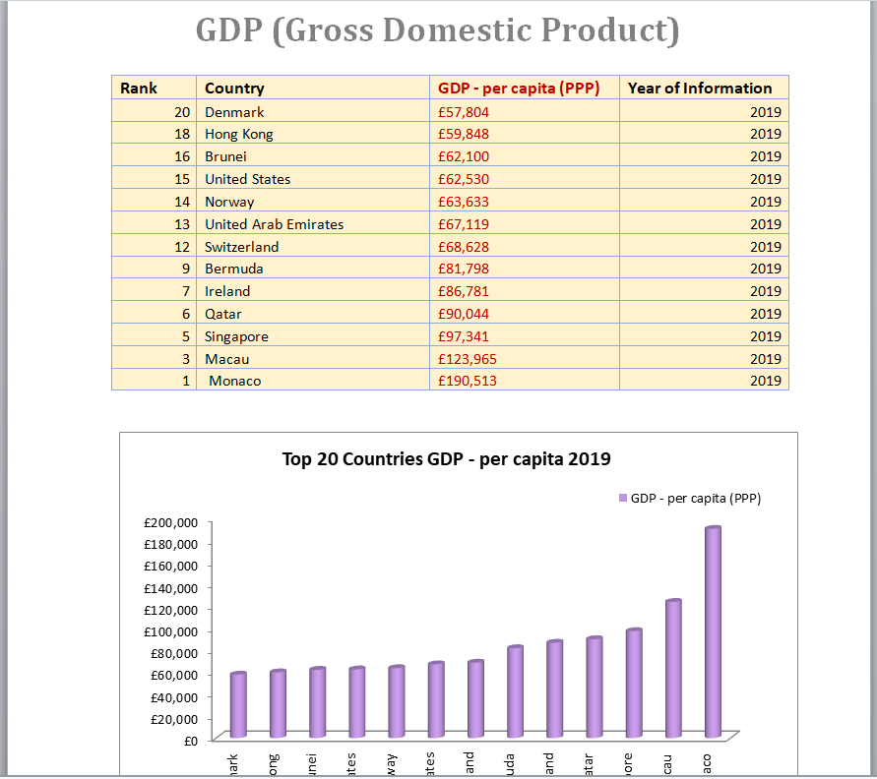

3. Saving the document as ‘Word Gross domestic product report 1’.

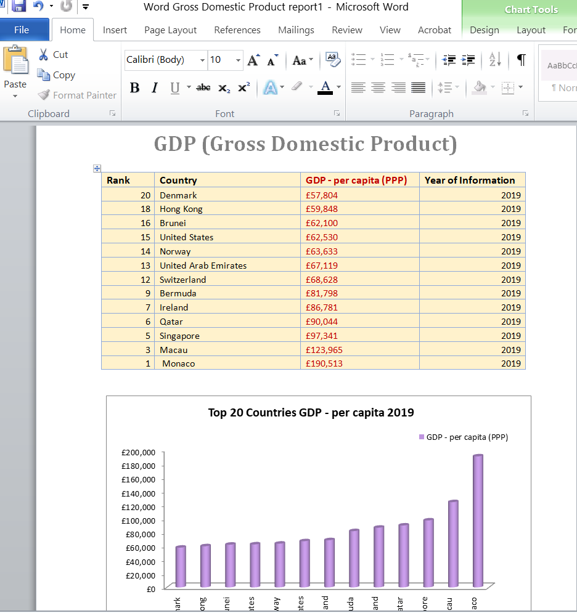

4, 5. Inserting header



6. Inserting footer



7. Saving the table as ‘Excel Gross domestic product report 1’.

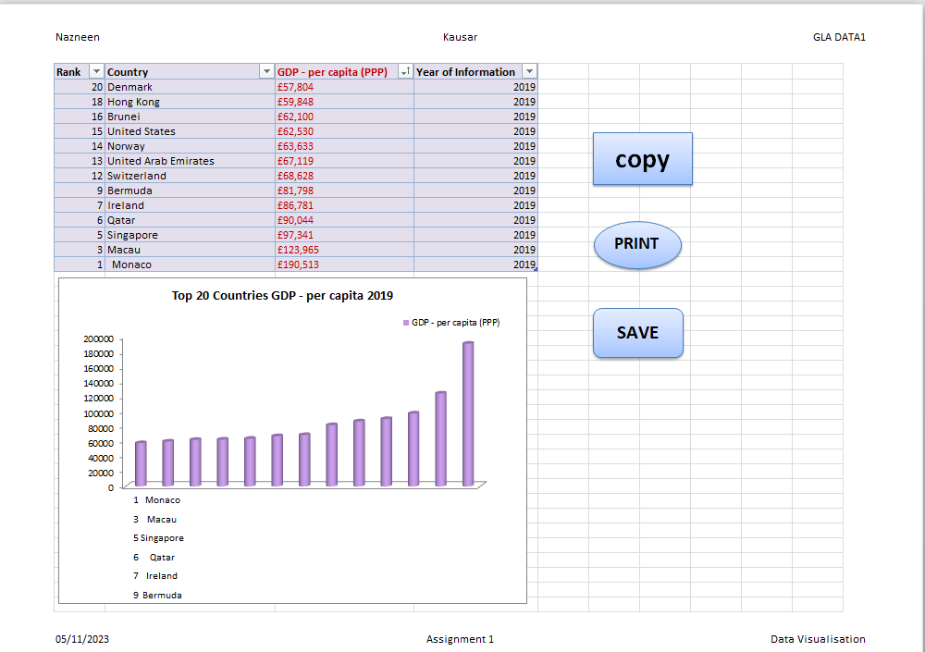

# Third Task

## *Tableau*

1,2 : Importing data and Set relationships:

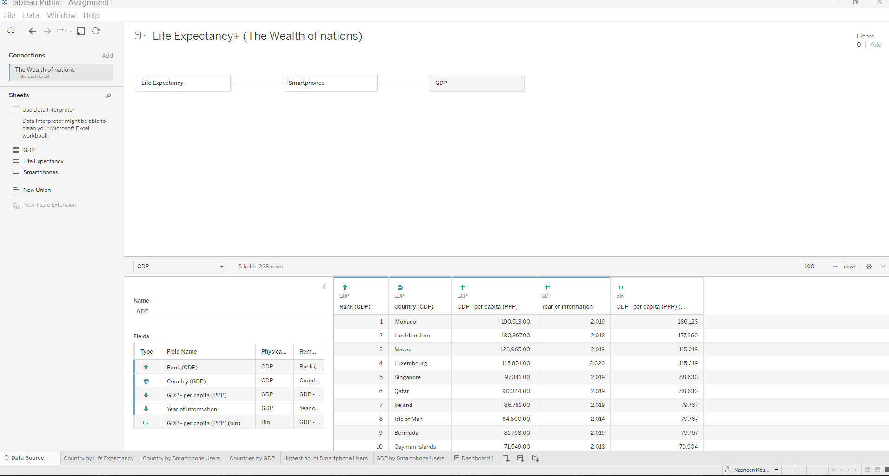

Sheet Displaying Top 20 Countries by Life Expectancy

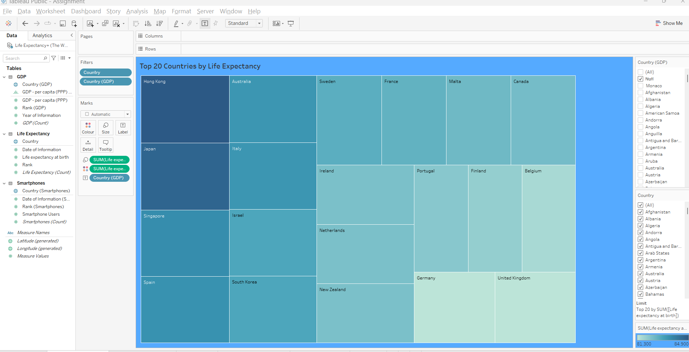

Sheet displaying Top 20 Countries by Smartphone Users

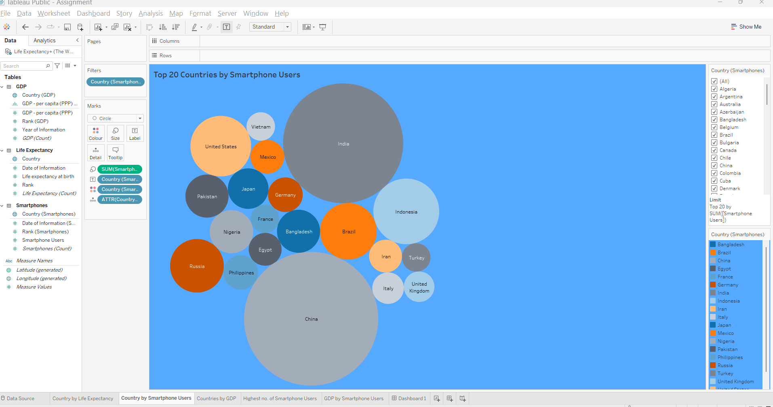

Sheet displaying Top 20 Countries by GDP

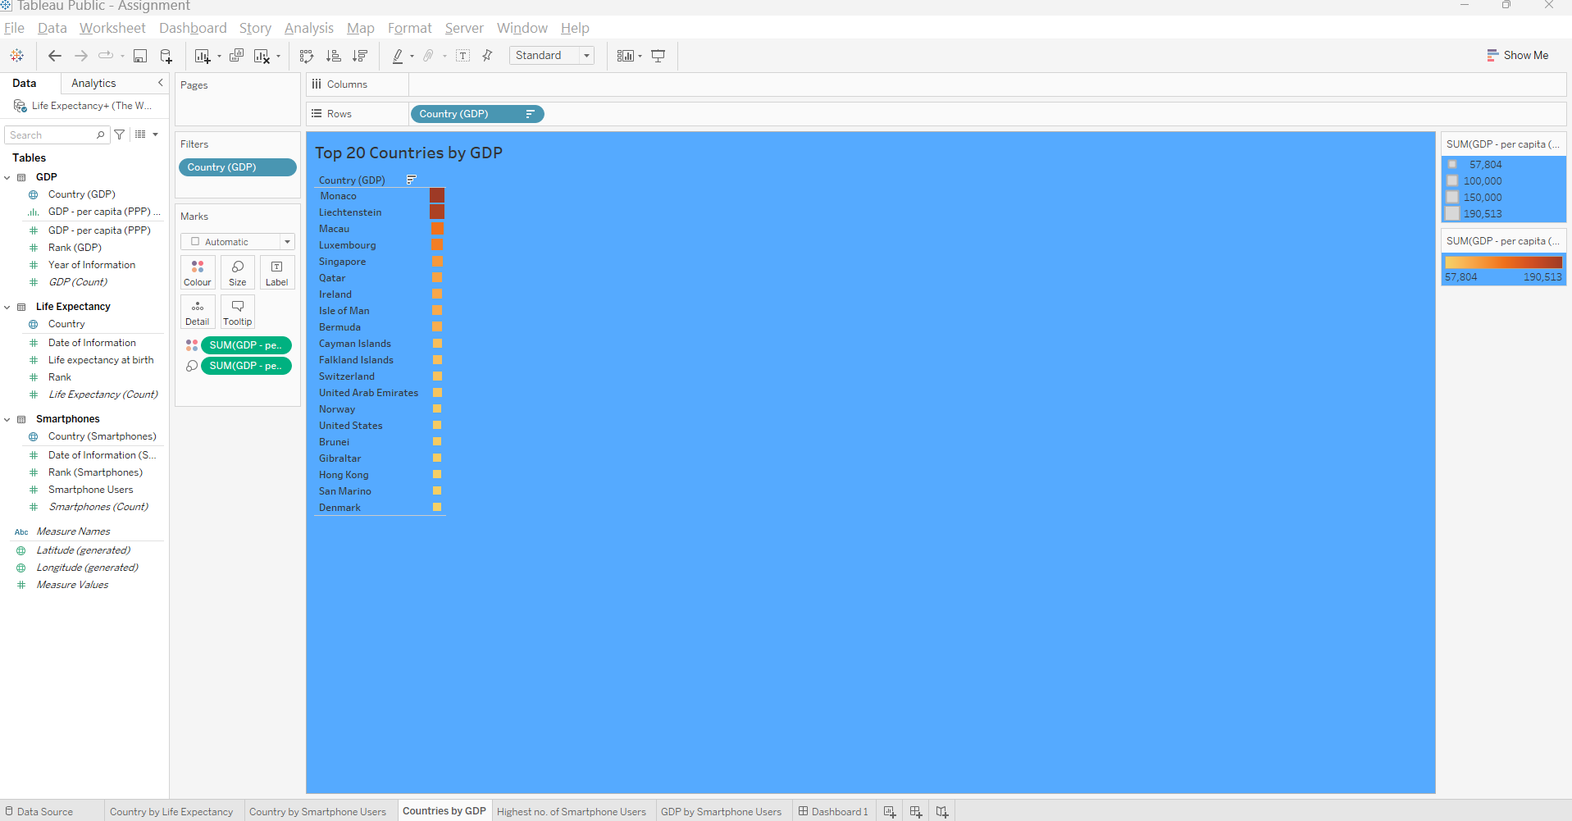

Sheet displaying Top 20 Countries with Highest Number of Smartphone Users

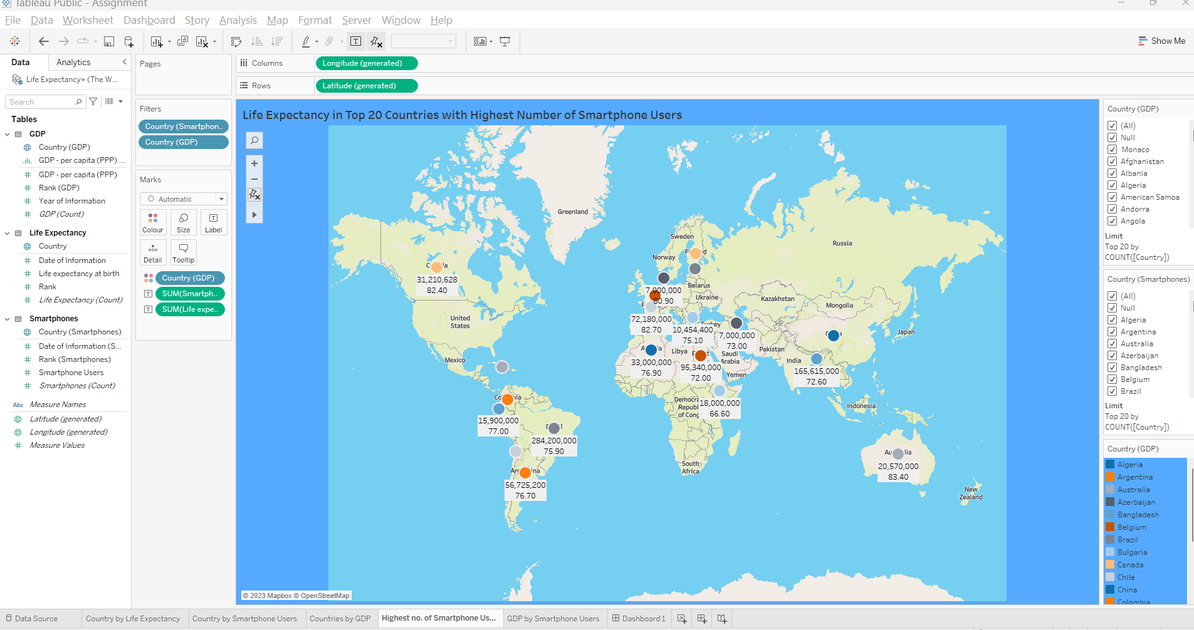

Sheet displaying Top 20 Countries with Highest GDP vs Smartphone Users

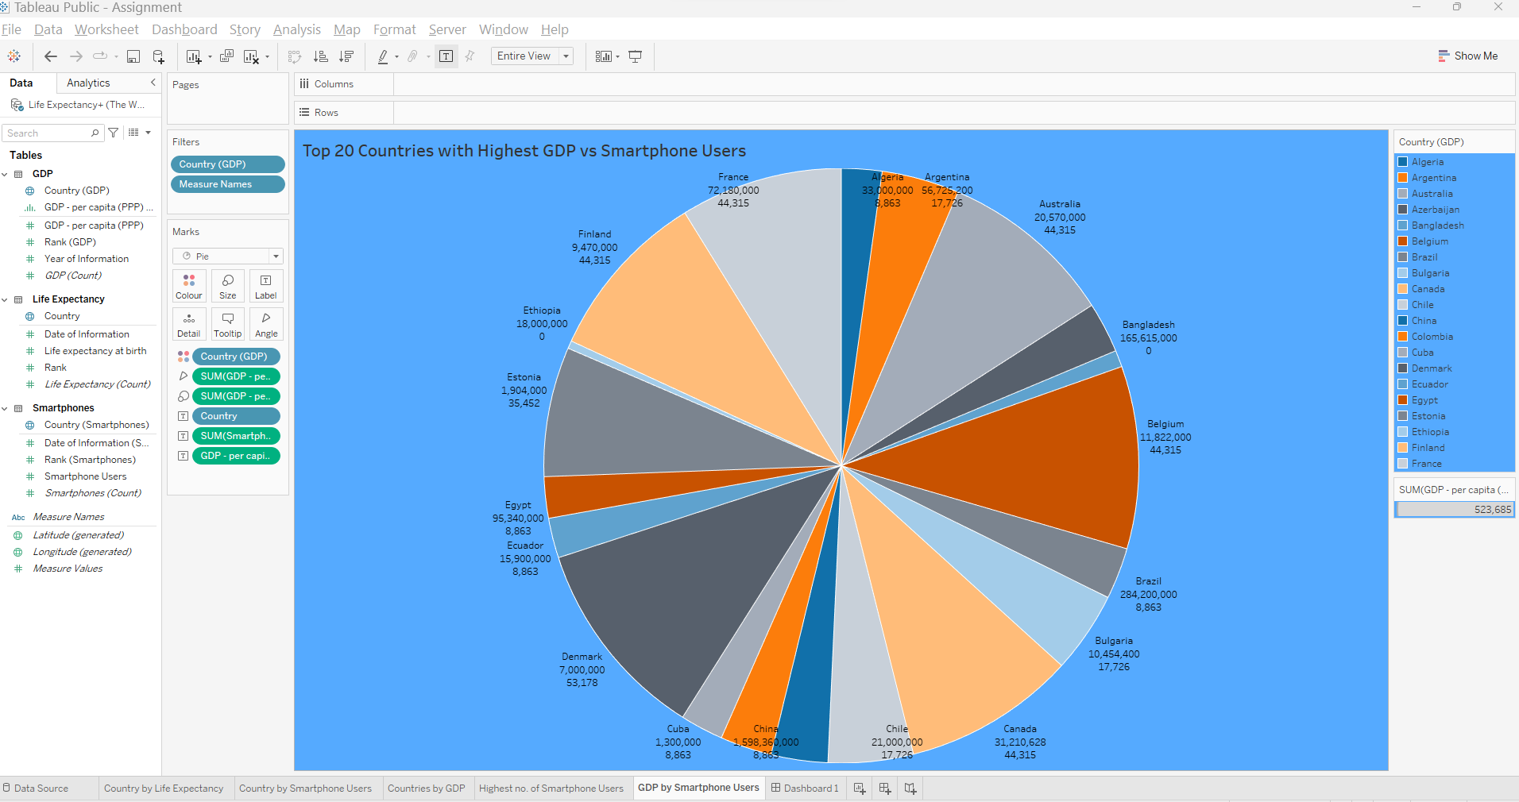

Final Tableau Dashboard (Colourblind-Friendly)

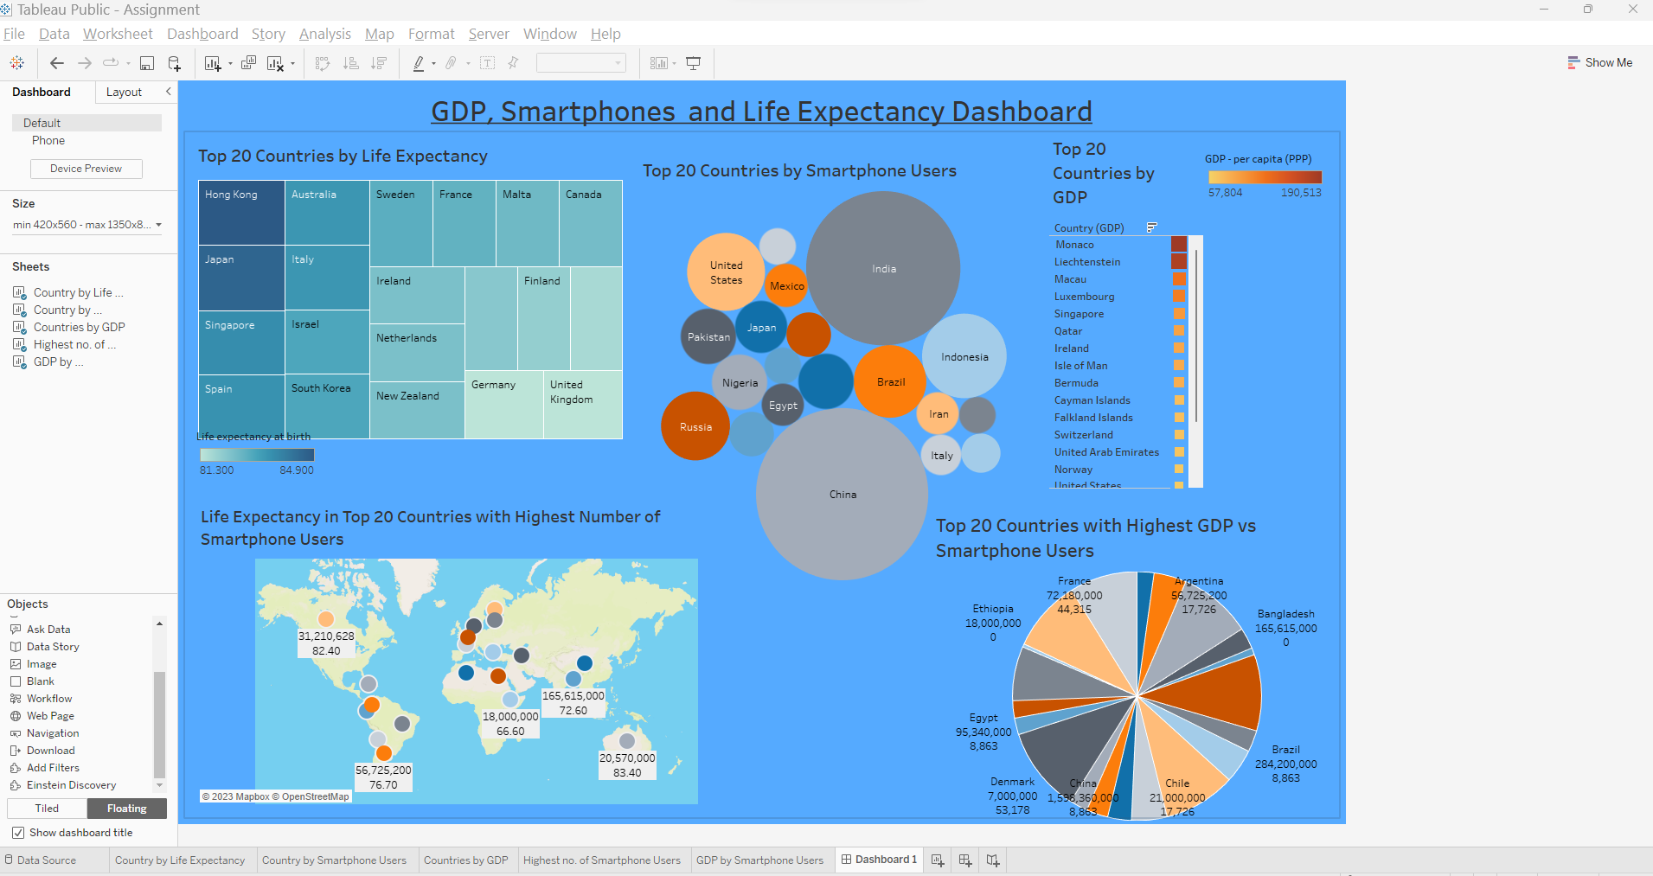

# Reflection

https://public.tableau.com/app/profile/nazneen.kausar/viz/Assignment_16992053442820/Dashboard1?publish=yes

During this project I have learnt a lot regarding data protection and I am now aware of GDP rules, policies and procedures when working with data. I now know the importance of securing and protecting data and keeping it safe from security threats and breaches.

I have gained an extensive knowledge of working with Data in Excel and how to use Macros as well.

I have enjoyed making an interactive dashboard on Tableau which I made sure to keep it colour blind friendly as per the client’s requirements.

I hope in future I am able to create more meaningful Dashboards putting much more sensible data insights into the picture.